CGI Tuto
https://openclassrooms.com/courses/apercu-de-la-cgi-avec-python

Reminder on for loops:
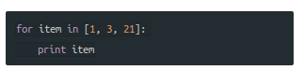

Remember the “:” after initializing the method!

A hash is called a dictionnary

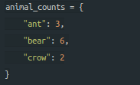
Exercise: inventory

We create two dictionnaries, stock and price, and want to display each fruit along with the price and stock available.

Need to add numbers inside a list together? => sum(list)

When you divide an integer with an integer, the result is always a rounded down integer. If you want a fraction, float(int1/int2)
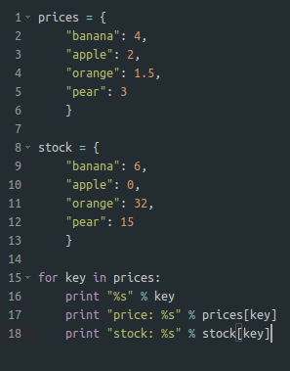
Next we want to see how much money we would make if we sold everything (so for each fruit, prices * stock)
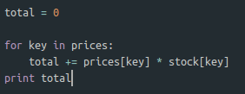

Reading files and custom data output
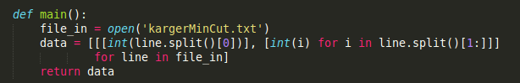
This will return a list of lists of lists, first taking the first element of a row for each row, the second grouping the rest.

